**Adaptive Robust Control of Multi-DOF Hydraulic Manipulator with Precise Online Load Estimation**

Qixian Wang a,b,#, Manzhi Qi a,b,#, Yangxiu Xia a,b, Shizhao Zhou a,b, Zheng Chen a,b,*

a State Key Laboratory of Fluid Power and Mechatronic Systems, Zhejiang University, Hangzhou 310027, China

b Ocean College, Zhejiang University, Zhoushan, Zhejiang, 316021, China

**Abstract**

The hydraulic manipulator has a broad application prospects in heavy load working conditions. However, compared with electric manipulator, it is more difficult for existing hydraulic manipulator to obtain high control precision because of joint coupling, uncertainties and high-order nonlinear dynamics. Unknown load mass is another important factor affecting the control accuracy. In some workplaces, the effective acquisition of load is a concern, but the load mass cannot be obtained accurately due to the lack of force/torque sensors. In this paper, a new load estimation method based on direct/indirect adaptive robust controller (DIARC) is proposed, which uses the backstepping strategy to cope with the high-order nonlinearity, and parameter adaptation method is applied to overcome the uncertainties which are incorporated into parametric space. Unknown load mass is included in the parametric space to realize its accurate estimation, and recursive least square adaptive law is adopted to estimate unknown parameters. Accurately estimated load mass can be further introduced into the controller to achieve better control performance. The performance of the controller is analyzed and tested on a four-degree-of-freedom hydraulic manipulator. The results indicate that the proposed method can achieve accurate online load mass estimation on the basis of high control performance.

Keywords: Hydraulic manipulator, Adaptive control, Load estimation.

**1. Introduction**

Hydraulic drive systems are extensively utilized in various industrial sectors, including oil and gas production, mining industries, civil engineering industries, and aerospace [1-3]. With the development of industrial automation, the number of workplaces that require precise operation continues to increase, such as collaborative pipeline assembly and equipment maintenance work [4]. As an intelligent hydraulic working equipment, multi-degree-of-freedom (DOF) hydraulic manipulators play an important role in various environments [5]. However, due to their low control precision compared to electric manipulators, the application of hydraulic manipulators is still limited [6, 7].

One of the reasons for the low control accuracy of hydraulic manipulators is the complex dynamic characteristics. The hydraulic system includes proportional valves, servo valves and many other components that may result in high-order nonlinearity such as Coulomb friction, viscous friction, and unknown external disturbances in the dynamic model [8-10], which makes it difficult for PID controller to achieve high control accuracy [11, 12]. To improve the control accuracy of hydraulic system, many researches were carried out. Shen e*t al*. proposed an adaptive integral terminal sliding mode controller to guarantee the robustness of double-variable hydraulic transformer and effectively improved the control effect [13]. B. Yao and Chen e*t al*. proposed an adaptive robust motion control theory to deal with the control of single-rod hydraulic actuators and the parameter uncertainty and uncertain nonlinearity of cylinder control systems [14-17]. J. Yao conducted extensive research on the parameter uncertainty of hydraulic systems and combined the RISE-based controller with parameter adaptive control to effectively suppress parameter uncertainty and reduce tracking errors of hydraulic systems [18–21]. Hou *et al.* proposed a force-free control method for compensating for friction, gravity, and inertia of hydraulic Stewart manipulators. By using separate compensation and complete compensation methods, the force-free control of the Stewart mechanism was achieved and good control effects were obtained on parallel robots [22]. While the aforementioned methods have achieved good control performance on the single hydraulic actuator platform, more complex control challenge remains on the multi-DOF hydraulic manipulators which is also limited by joint coupling and other factors [5, 23]. Mattila *et al.* proposed the virtual decomposition control (VDC) method for multi-DOF hydraulic manipulators [24-26]. Ahn *et al.* proposed a sliding mode control algorithm using a finite-time disturbance observer [27] for a 3-DOF hydraulic manipulator considering the actuator dynamics and the joint tracking errors were guaranteed to converge to zero in finite time under the strong assumption that the uncertain joint dynamics were time invariant.

Another factor to affect accuracy is the unknown load mass at the end effector. In many heavy-duty and harsh operation occasions, it is difficult to implement force/torque sensors at the end effectors to estimate the mass of the load. As the load of the manipulator is unknown and time-varying, the dynamic characteristics of the manipulator is influenced hence. Accurate online load estimation which can compensate for the unknown load and effectively improve control precision is needed. In addition, online load estimation is also necessary in industries such as workpiece handling and cargo sorting Many studies investigated the unknown load changes of machinery. Lin *et al.* developed a load sensing system based on displacement adaptive and variable speed control for electric hydraulic excavator, considerably improving its control performance [28]. Duan *et al.* proposed a variable structure robust control method based on equivalent control and a feedforward compensator for robots with load uncertainty, achieving better control effects under the condition of no force sensor at the end effector [29]. Sun *et al.* analyzed a novel natural adaption law which achieved accurate control for redundant manipulators when picking tools with unknown length, direction, and mass, and the parameter estimation speed was also increased [30]. Zeng *et al.* and Colomé *et al.* explored methods for estimating the load conditions of electric rigid manipulators [31, 32]. Bartlett *et al.* and Tessari *et al.* considered the parameter uncertainty of load mass for single-rod hydraulic knee prostheses [33, 34]. Renner *et al.* proposed online payload estimation method and achieved high estimation performance in earthmoving excavator [35]. However, more research on load compensation and estimation of hydraulic manipulator is needed.

In order to address the above issues and enhance the control precision of the hydraulic manipulator, a load estimation based direct/indirect adaptive robust controller (DIARC) is designed in this paper. The controller eliminates the influence the nonlinearity of the model and the unknown external disturbance while ensuring the stability of the system. Furthermore, the load is incorporated into the model as a state on the basis of considering the control accuracy. The unknown weight load at the end effector is estimated by a parameter estimation method.

**2. Problem formulation**

* 1. **Dynamic modeling of hydraulic manipulator**

The schematic diagram of a multi-DOF manipulator is shown in Fig. 1. For the convenience of dynamic modeling, it is supposed that the centroid of each link is at its center. Therefore, the dynamic model of a *n*-DOF manipulator is established using Lagrange method as:



where  and  are the Coulomb friction coefficient and viscous friction coefficient, respectively.  is the matrix of modeling uncertainty. The joint control torque  is calculated by



where  is the joint Jacobian matrix,  is the length of the cylinders, is the control force of the hydraulic cylinders,  and  represent the area and pressure of the cylinders with rod,  and  represent the area and pressure of the cylinders without rod. The matrix of inertial , the matrix of Coriolis force and centrifugal force  and the matrix of gravity  can be written as:



where ,  and  represent additional terms generated due to the unknown load mass. Their detailed expression can be found in the appendix.



**Fig. 1. Schematic diagram of the manipulator**

According to Ref [36], the joint dynamics model can be expressed as:



where  is the elastic bulk modulus of hydraulic oil,  is the modeling uncertainty.

The following static mapping can describe the relationship between  and valve control voltage  as follows:



where  and are the flow gain coefficient of the valve,  the linearized flow gain of the valve,  and  the supply pressure and the reference pressure of the *i*th cylinder respectively.  and  denote the volumes of the cylinders with and without rod respectively.

* 1. **Parameterization of the dynamic model**

Parameters such as the mass, moment of inertia, and coefficient of friction of the joints are unknown. Hydraulic systems also have the characteristics of uncertainty and nonlinearity. To facilitate subsequent controller design, the unknown parameters and nonlinearities are parameterized as:



where  represents the parameter set of the *i*th physical parameter in *n* DOF,  represents the parameter set of the *j*th DOF and  is the mass of the *j*th link. For parameters that only appear once in the parameter set, defining , . In Eq.6,  is the low frequency calculable part of .

The general dynamics and the hydraulic dynamics of the manipulator have the following properties.

**Property 1**

For a certain form of , the general dynamics and the hydraulic dynamics of the manipulator can be expressed in the form of linear regression as follows:





where  are linear regression matrixes.

**Property 2**

Due to the boundary limitations of the above unknown quantities in practice, the following assumptions can be made:



where  is a known vector.

* 1. **Control objective**



**Fig. 2. The algorism diagram of the controller**

The first target is in this paper to generate the valve control voltage  in Eq. 5. Therefore, the tracking accuracy of each joint of the manipulator can be achieved, despite noise and unknown load mass. The second target is to make precise estimation of the unknown load mass in a comparatively short time, *i.e.*, to make  converge to its real value.

1. **Control of the manipulator**
   1. **Controller design**

The algorism diagram of DIARC controller is shown in Fig. 2. Backstepping strategy is adopted to cope with the uncertainty and nonlinearity of hydraulic dynamics.

**STEP Ⅰ.**

The angular error is defined as:



where  is the actual angle of each joint, and  the desired angle of each joint.

The angular velocity error is thus defined as:





where  and  are a positive definite diagonal matrix.

Then, the control object is to make  converge to 0. Based on property 1, Eq.1 can equally be written as:



where  is also a linear regression matrix.

Eq.1 minus Eq.13 and consider Eq.2, we can get:



where  is the virtual force input.

Let  represent the estimation of , and  is the error between the real value and the estimation.  can be dismantled into the following parts:



where  is designed to compensate nonlinearities.  is the fast-dynamic compensation item which will be designed in STEP Ⅱ.  can keep the system stable if  is a positive definite diagonal matrix.  is set to compensate the parameter uncertainties, which be designed in STEP Ⅱ. If we nominate the force tracking error as Eq.16, according to Eqs.14 and 15, the derivatives of  can be written as:





**STEP Ⅱ.**

Based on Eq.8, the derivatives of  can be further expressed as:



 can be dismantled into the calculable part  and the incalculable part , that is:



where  is the estimated value of .

If we consider Eq.19, Eq.18 can be expressed as:



Similar to the design of virtue forth input, virtual flow input  can be written as:



whereis the backstepping compensating item,  and  are two constant matrixes that are used to balance the order of magnitude. In Eq.21,  is designed to compensate nonlinearities, while  is the fast-dynamic compensation item.  can keep the system stable if  is a positive definite diagonal matrix.  is set to compensate the parameter uncertainties, which will be designed later. Based on Eqs.20 and 21, can be described as:



Since  is a positive definite diagonal matrix.  can converge to 0 if the small quantities are ignored.

So far, the stability of the system is ensured and the compensation of nonlinearities is completed. Now, design  and  as fast-dynamic compensation items. They will play a significant role in reducing the dynamic error. The modeling uncertainty and parameter estimation error in Eqs.17 and 22 can be divided into the low frequency part  and high frequency part , that is:



Fast dynamic compensation items can thus be designed as:



where  is the estimation of .  can be updated by the following adaptation law:



where  is a positive definite diagonal matrix and  the upper bound of . Eqs.17 and 22 can then be written as:



 and  must satisfy the following conditions:

1. Condition 1



1. Condition 2



where  and  are constants. One possible form of  and  can therefore be expressed as:



where  is the upper limit of  and  are positive definite diagonal matrixes.

By now the design of  has finished and the valve control voltage  can be obtained from Eq. 5.

* 1. **Least squares parameter estimation**

In the previous steps,  is designed to replace , and it is enough to ensure basic tracking accuracy. In this part, a least squares parameter estimation law is proposed for fast estimation of .

The virtual control torque  can be expressed as:



To eliminate the noise caused by insufficient sensor accuracy, a first-order differential device is designed here. It has the following property.

**Property 3**

The first-order differential device has the following form:



where  is the filtered , the updated ,  the time constant selected for first-order differential filtering and  the sampling time. After filtering, the first equation in Eq.30 is described as Eq.32 and its estimation error can be expressed as Eq.33.





The positive definite gain matrix can thus be expressed as:



where  is the forgetting factor and  the upper bound of the projective adaptive law, , and all the elements in  are positive. Then, the projective adaptive law can be written by:



The projection function that satisfies Eq. 9 should be designed to bound the uncertain parameters. One of the possible choices would be:



where  and  denote the interior and boundaries of the parameter sets, respectively. is the unit normal vector pointing to the external world when  is at the boundary.

Eq.36 is used to update. To achieve fast parameter adaptation effect, parameters should be carefully adjusted. It is noteworthy that  should be as small as possible to minimize the impact of older data on new data. Conversely,  should be large enough so that the speed of parameter convergence can be maximized.

Due to the frequent changes in unknown load mass under actual working conditions, if the  cannot be updated quickly, the control accuracy will be difficult to ensure. Eq.36 indicates how  is updated. However, it cannot guarantee that  can be large enough to quickly update . When the load of the manipulator changes, it can be considered that the adaptive value of  has fallen into local optima. At this time,  should be modified to drive the adaptation of  and make it jump out of local optima.

The objective function is shown as:



where  and  is the last item in . Subsequently,  follows the modification law expressed as:



where  is the original parameter of ,  and  are known functions.

**Theorem Ⅰ**

All the signals in the system are bounded. If a positive-definite function is defined as , then the following inequality is satisfied:



where , .

**Theorem Ⅱ**

If the persistent excitation condition is satisfied,  is able to converge to its real value in the presence of parameter uncertainty only. Based on theorem Ⅰ, zero angular tracking error can be achieved, i.e.,  when .

**Remark Ⅰ**

Theorem Ⅰindicates that the controller possesses exponential converging rate. Theorem Ⅱ demonstrates that uncertain parameters such as  can be estimated online and the negative impact of parameter uncertainty can be eliminated through parameter estimation.

**4. Simulation**

In the simulation, a four-DOF hydraulic manipulator is modeled using MATLAB and Simscape Multibody. The angle coupling, friction and gravity are all taken into consideration. The parameters of the links and hydraulic systems are strictly consistent with the real manipulator. In the simulation, a spherical object with a mass of 10kg and a radius of 0.04m is fixed in the gripper of the manipulator. The distance between the center of the weight and the rotation axis of joint-4 is set to 0.4m. Point-to-point trajectory is used in this experiment, as shown in Fig.3.

The control methods used in the simulation are explained as follows:

**C1:** PID controller with coefficients being tuned to enhance the tracking accuracy.

**C2:** DIARC controller with load compensation.

**C3:** DIARC controller without load compensation. Similar to C2, but the unknown load  will not be compensated, i.e. . The other parameters are the same as C2.

Fig.4 shows the tracking error of the three methods. The control accuracy using C1 is the lowest, with the maximum error of joint-2 reaching 0.13 rad. C3 can achieve much better performance than PID controller. C2 has the best control accuracy in all four joints, that the max errors decrease by 29.75%, 67.25%, 43.96% and 40.04%, respectively.

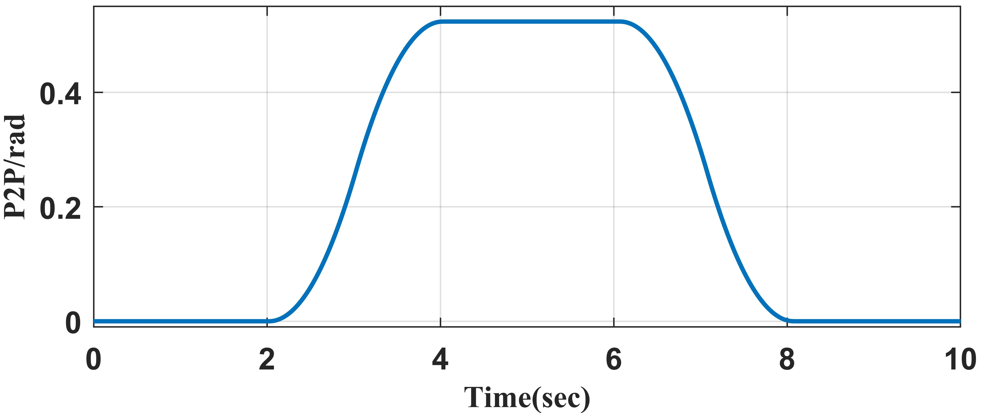

**Fig. 3. The trajectory in the experiment and simulation**

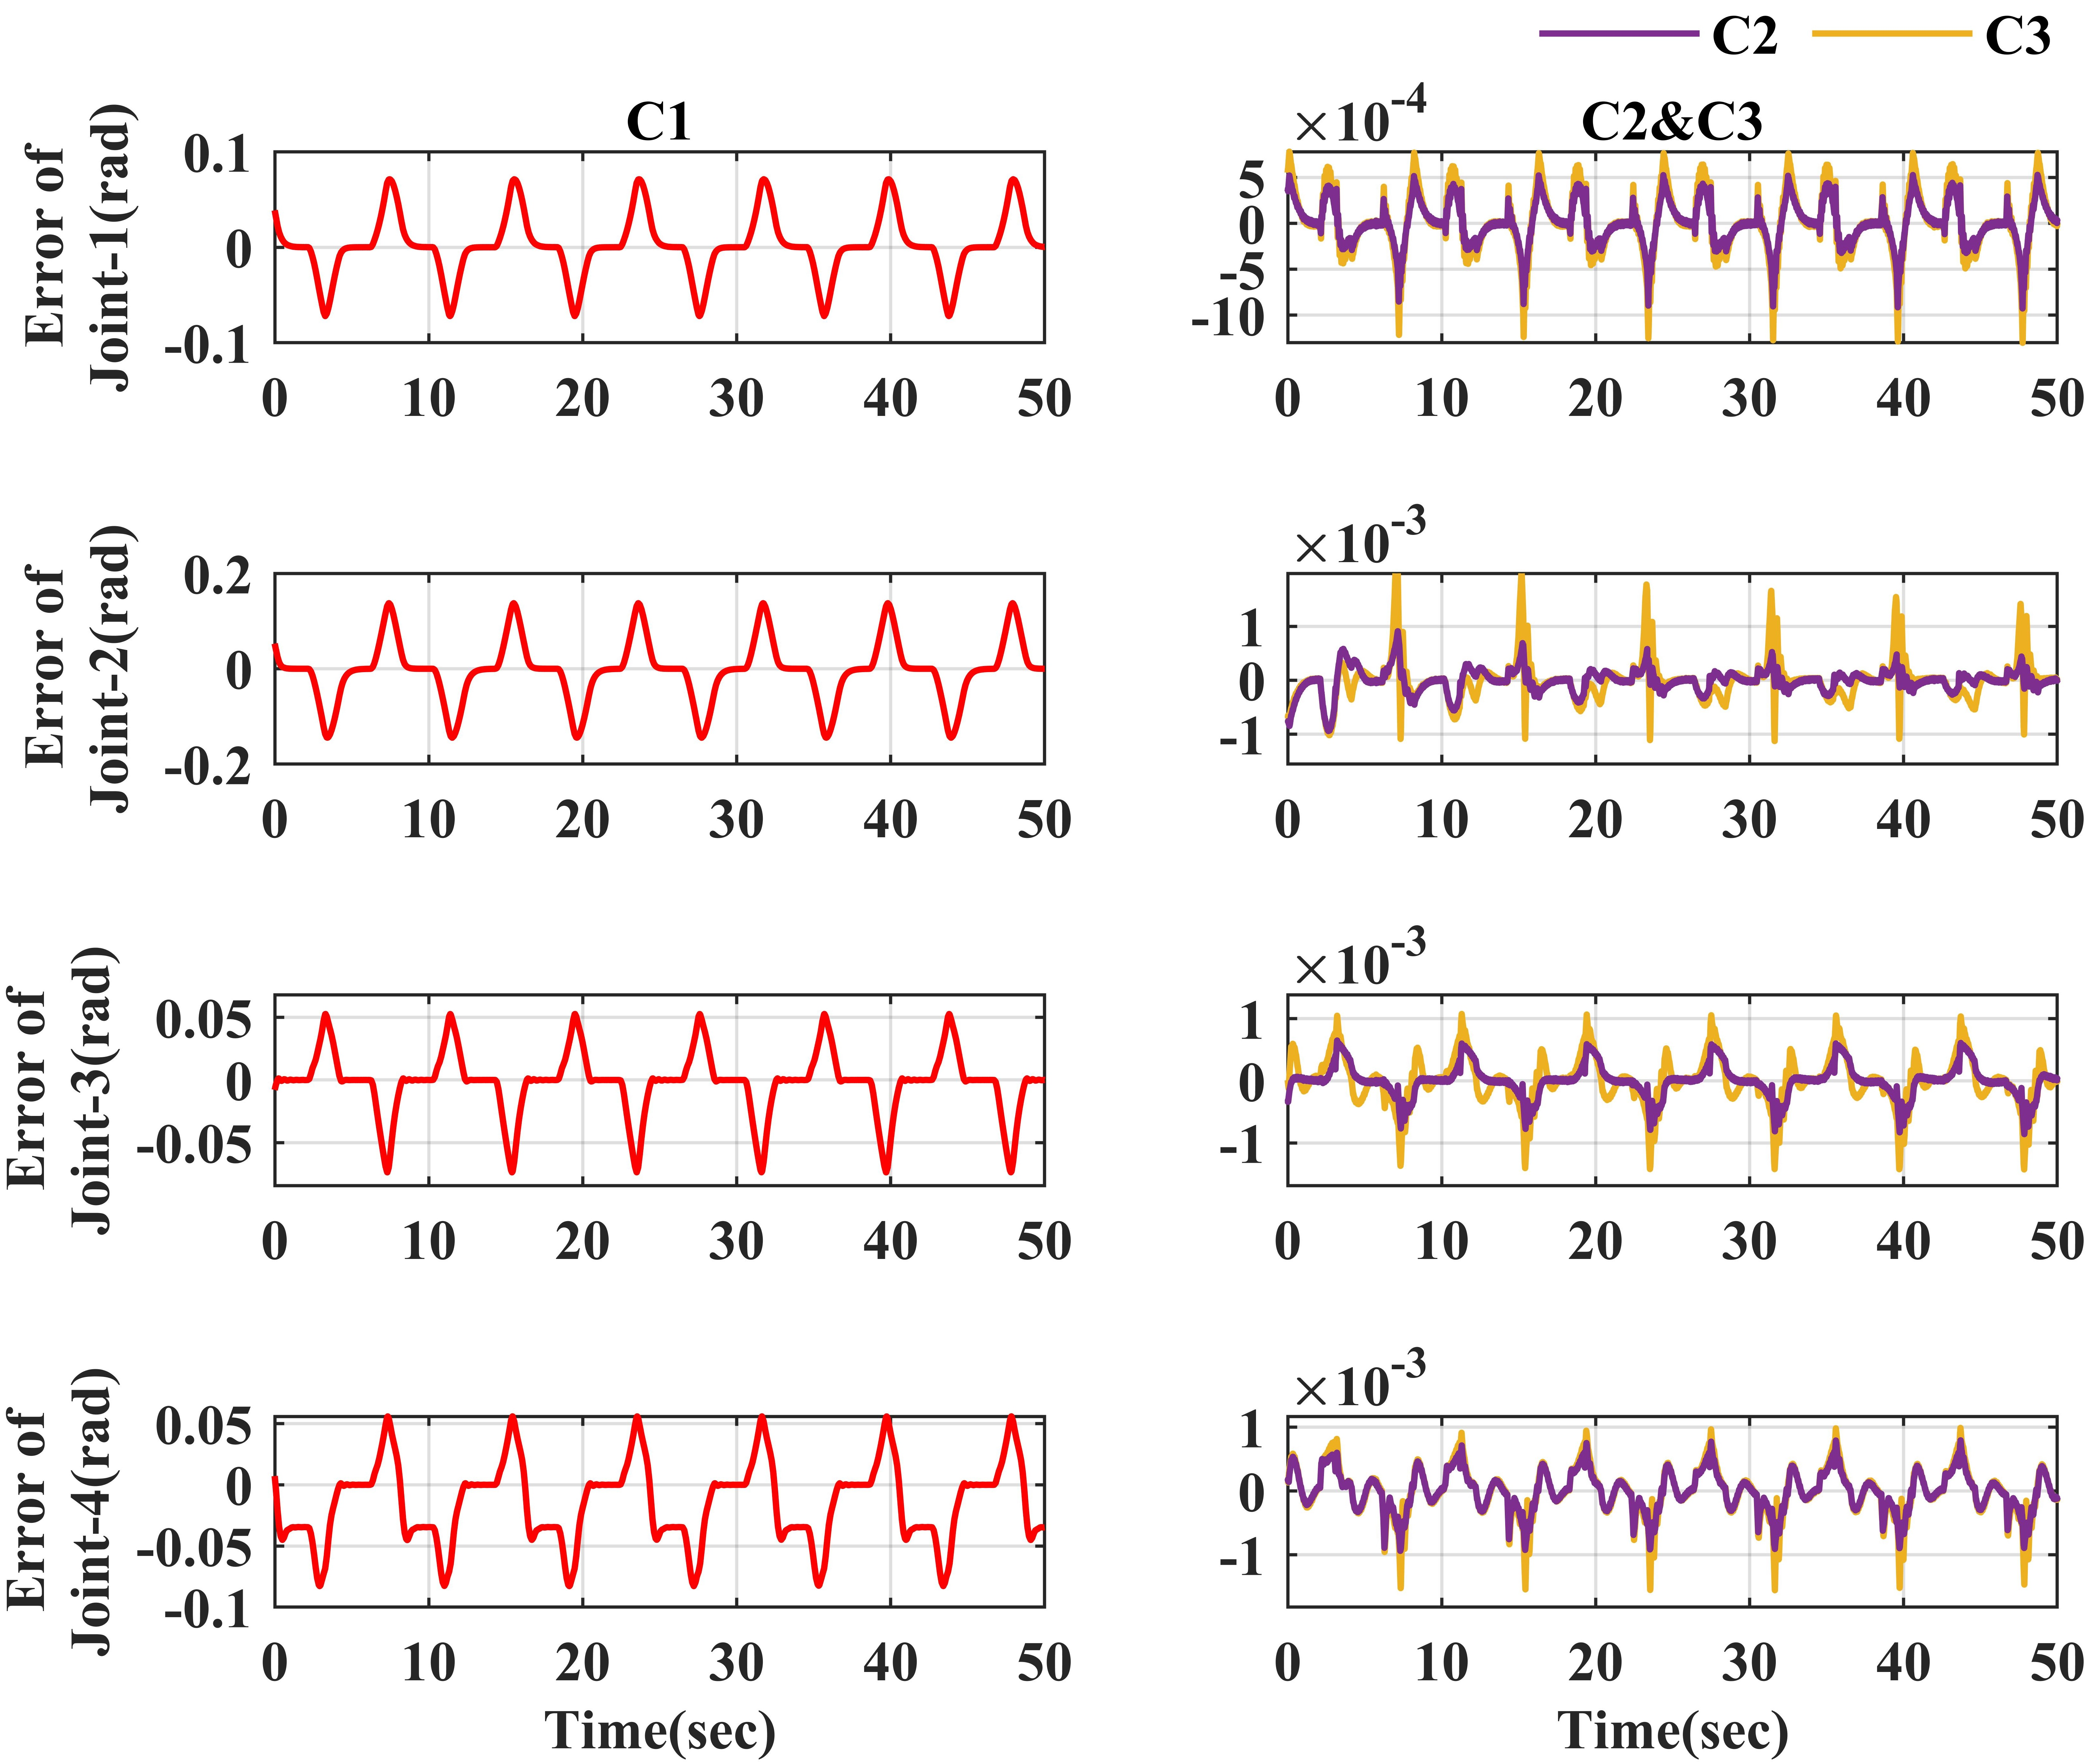

**Fig. 4. Simulation results on tracking accuracy**

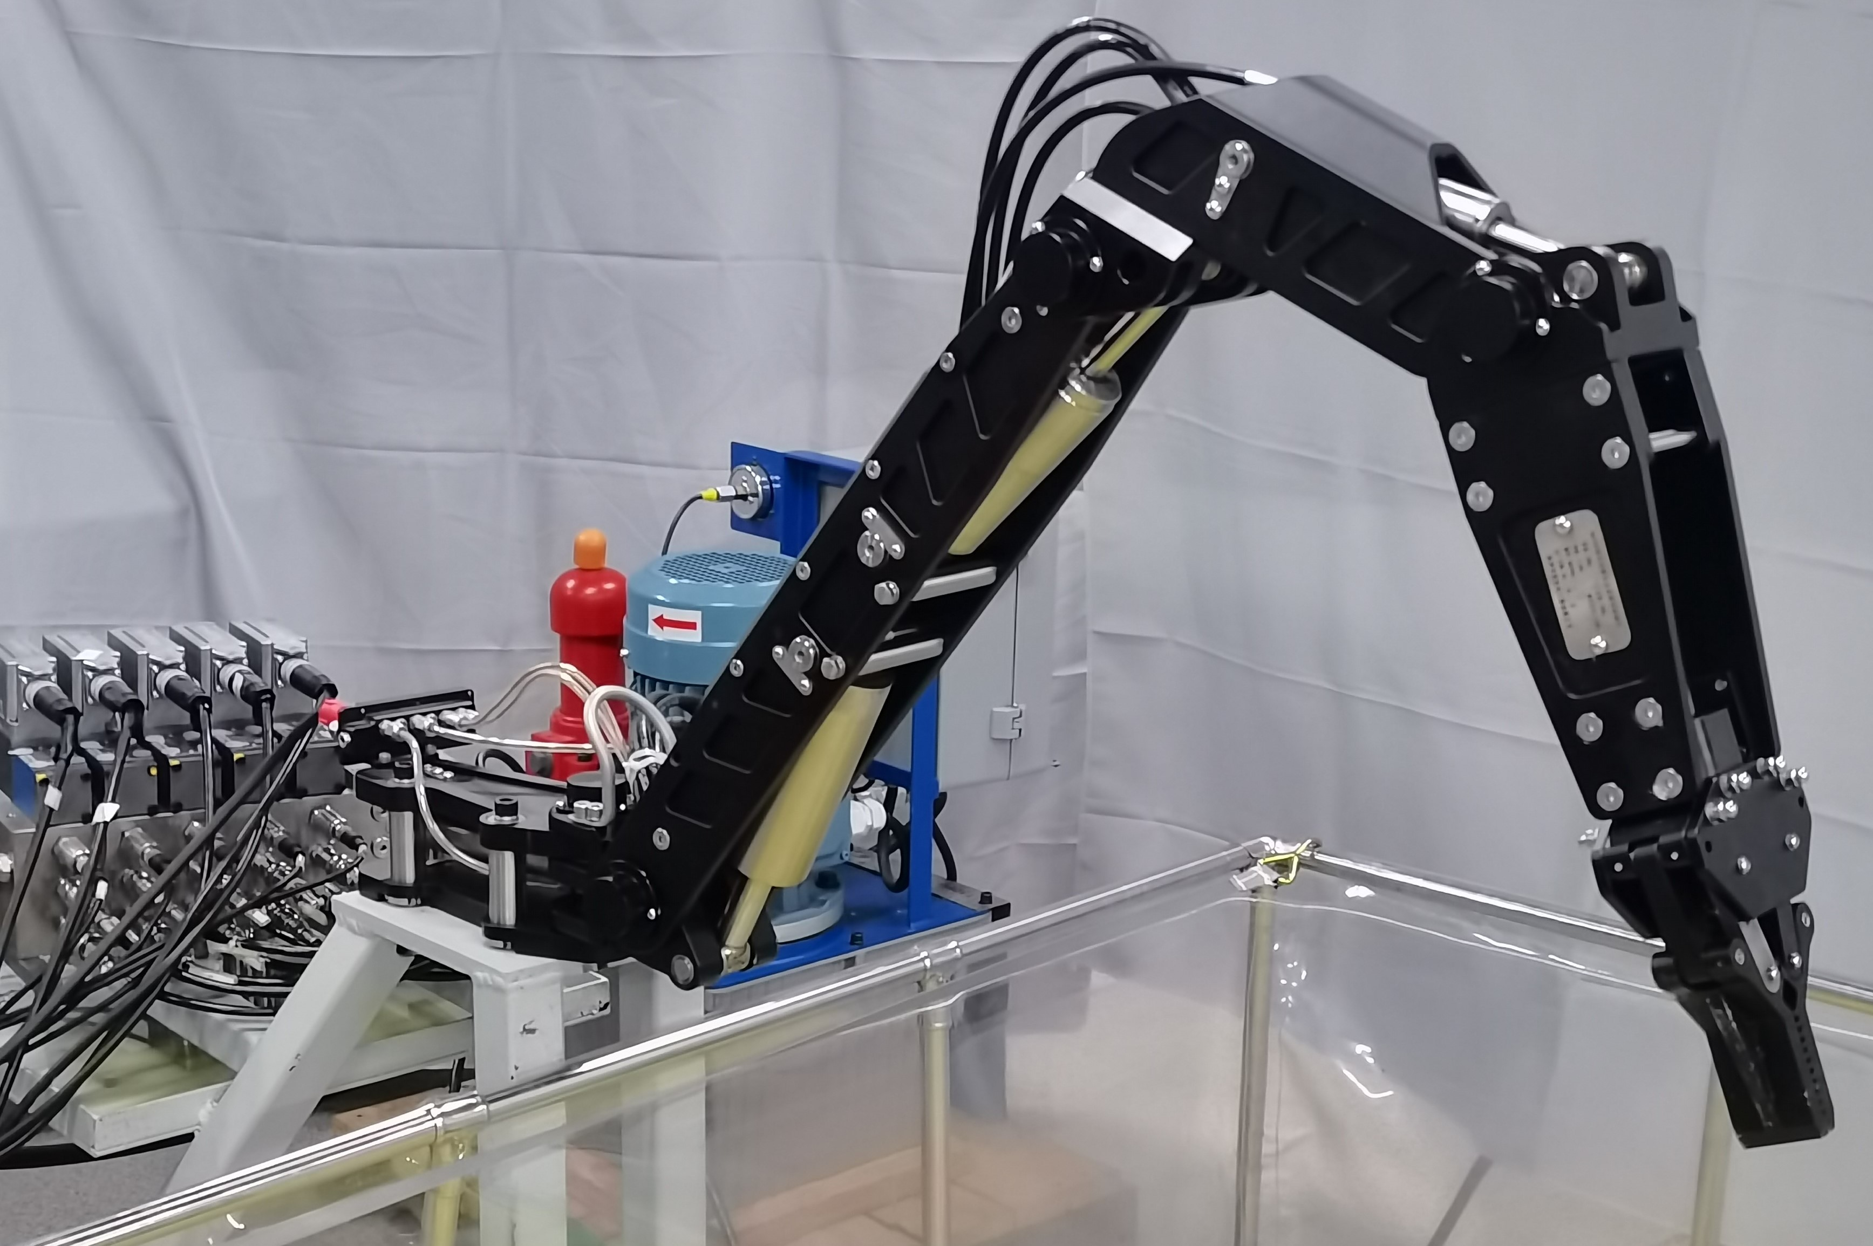

**Fig.5. The tested four-DOF manipulator**

**5. Experiment setup**

* 1. **Hardware platforms**

The tested four-DOF manipulator is shown in Fig.5. The hydraulic system of the manipulator has the pump driving motor (ABB M2BAX-112MA-4), with rated power being 4KW and maximum output flowrate being 12L/min. It installs two pressure sensors (GEFRAN-KS-E-E-Z-B16D M-V-530) to measure the pressure of each chamber. There are four angle sensors (Melexis-MLX90316) located on each joint. Quarc QPID-e and Q8-USB are utilized to process the data collected by the sensors. The overall sampling time is set to be 25ms.

* 1. **Experiment design**

To verify the effectiveness of the algorithm for precise motion control and precise load estimation, two sets of experiments were designed as follows：

**Set 1:** PID trajectory tracking experiment. The end of the manipulator grabs a heavy object with unknown mass, and each joint tracks the P2P trajectory while changing the load mass multiple times to test the effectiveness of the proposed algorithm for precision control and load estimation.

**Set 2:** Simulation of common handling tasks. The manipulator grabs a heavy object at starting point and transports it to the designated end B, while estimating the mass of the unknown load in real-time.

Using the parameters in simulation as reference, the coefficients in the experiment are set as follows:

**Table 1** Coefficients of C2

|  |  |
| --- | --- |
| Coefficients | Value |
|  |  |
|  |  |
|  |  |
|  |  |
|  |  |

**Table 2** Control performance of each controller

|  |  |  |  |  |
| --- | --- | --- | --- | --- |
| Controller | Angle | Maximum error (deg) | RMSE  (deg) | IAE  (degs) |
| C1 | Joint-1 | 636 | 300 | 1210 |
| Joint-2 | 1819 | 5100 | 5378 |
| Joint-3 | 2067 | 6800 | 6350 |
| Joint-4 | 1135 | 1200 | 2687 |
| C2 | Joint-1 | 77 | 4.304 | 201.5 |
| Joint-2 | 107 | 8.358 | 261.98 |
| Joint-3 | 120 | 7.538 | 202.56 |
| Joint-4 | 99 | 5.01 | 194.28 |
| C3 | Joint-1 | 115 | 8.4 | 264.89 |
| Joint-2 | 151 | 8.367 | 279.13 |
| Joint-3 | 139 | 10.97 | 261.21 |
| Joint-4 | 155 | 18.43 | 352.47 |

**C1:** PID controller. The control coefficients are , , .

**C2:** DIARC controller with load compensation. The coefficient settings are shown in Table 1.

**C3:** DIARC controller without load compensation.  and other coefficients are the same as C2.

**6. Experiment results**

**Set 1:**

Fig.6 shows the tracking performance of each controller. Table 2 lists the maximum tracking error, root mean squared error (RMSE) and integral absolute error (IAE). It can be seen that C1 is far inferior in control accuracy to C2 and C3 because the complex dynamics of the hydraulic manipulator is considered. For DIARC controllers, load compensation also has a significant effect. In C2, the control accuracy of joint-2, joint-3 and joint-4 which is directly affected by the unknown load mass has greatly improved. Compared to C3, the maximum errors of the joints decrease by 29.14%, 13.67% and 36.13%, respectively. Due to the high estimation accuracy of the unknown load mass, the maximum error of the joint-1 also reduces by 33.04%. RMSE and IAE of all joints also decrease evidently.

**Fig. 6. Experiment results on tracking accuracy**

For C2, accurate parameter estimation is an important feature. The adaptive curves of all parameters of the controller are shown in Fig.7. It demonstrates that each parameter converges to a certain value and the convergence value is largely trustworthy.

Additionally, the manipulator is operated under no-load, loads of 2.5kg, 5kg, and 7.5kg respectively. For each unknown load mass (including no-load), the manipulator runs repeatedly and collect ten sets of data. The average, maximum, and minimum values, RMSE and standard deviation (SD) list in table 3.

From the experimental data, the average estimation error is always below 5%, and the maximum error does not exceed 10%. Although the estimated values of mass witness certain fluctuation, with the maximum difference reaching 0.79kg, the average estimated value is close to the actual value. It depicts that the developed controller has an ability to achieve estimation accuracy.

In practical engineering, the unknown load mass of a manipulator is often time-varying. Two scenarios are set up to test the controller's real-time estimation of changing loads. In scenario-1, the unknown load mass continues to increase by 0kg, 2.5kg, 5kg, and 7.5kg, respectively. In scenario-2, the unknown load mass switches between 0kg and 2.5kg. The adaptive curves are shown in Fig.8.

**Fig. 7. Adaptive curves of all parameters**

Evidently, in both scenarios, the adaptive curve converges to the actual values. In the adaptive curve of scenario-1, the intermediate transition state is marked with backup color. During this period, the load is changed and  modification (expressed in Eq. 38) is performed, which is indicated by a spike of the adaptive curve. The duration of this transition state is short, and the parameters will continue to converge to the true value afterwards. The time interval for estimation is short with 10-15s on average and the average estimation error in the experiment is 3.89%.

**Table 3** Statistic data in load estimation accuracy

|  |  |  |  |  |  |  |
| --- | --- | --- | --- | --- | --- | --- |
| Mass kg | Avg. kg | Max. kg | Min. kg | RMSE kg | SD kg | Error (%)  (Avg./Max./Min.) |
| 0 | 0.175 | 0.35 | -0.1 | 0.018 | 0.142 |  |
| 2.5 | 2.607 | 2.74 | 2.42 | 0.015 | 0.127 | 4.3/9.6/3.2 |
| 5 | 5.14 | 5.33 | 4.80 | 0.062 | 0.263 | 2.8/6.6/4.0 |
| 7.5 | 7.71 | 8.12 | 7.33 | 0.055 | 0.247 | 2.8/8.3/2.3 |



**Fig. 8. Adaptive curves with unknown load**

**Set 2:**

In this experiment, a common handling task is performed. The manipulator will carry a weight of 2.5kg and 5kg respectively. The trajectory in joint space and Cartesian space is shown in Figure 9. The tracking results in joint space are shown in Fig. 10. The maximum tracking error occurs at around 9s when the angular velocity witnesses a significant change. But this transient error does not exceed 0.7 degree, and in most cases, the error is limited to within 0.2 degree. Additionally, the tracking results in three dimensions of the Cartesian space are manifested in Fig. 11. Generally, the error in all directions can be stabilized within 0.5cm, and the maximum error is limited to within 1cm. Meanwhile, it is noted that when the load mass changes from 2.5kg to 5kg, there is no significant change in maximum error and dynamic error, indicating that the compensation for the load mass is effective. To conclude, the designed controller can compensate for unknown load mass and achieve high control accuracy.

The adaptive curves for the two handling tasks are illustrated in Figure 12. The system feels the heavy object being picked up at the beginning and activates the modification of , which results in the spike of the curve. At 10s, the curved become relatively stable and gradually converge to the actual values, and it takes around 40 seconds to truly converge to the actual value. In this experiment, the frequency width of velocity

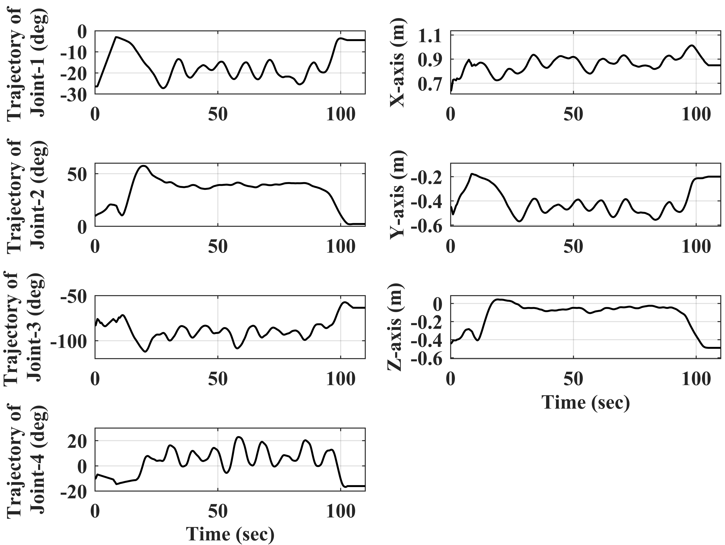

**Fig. 9. Desired trajectory of Set-2**

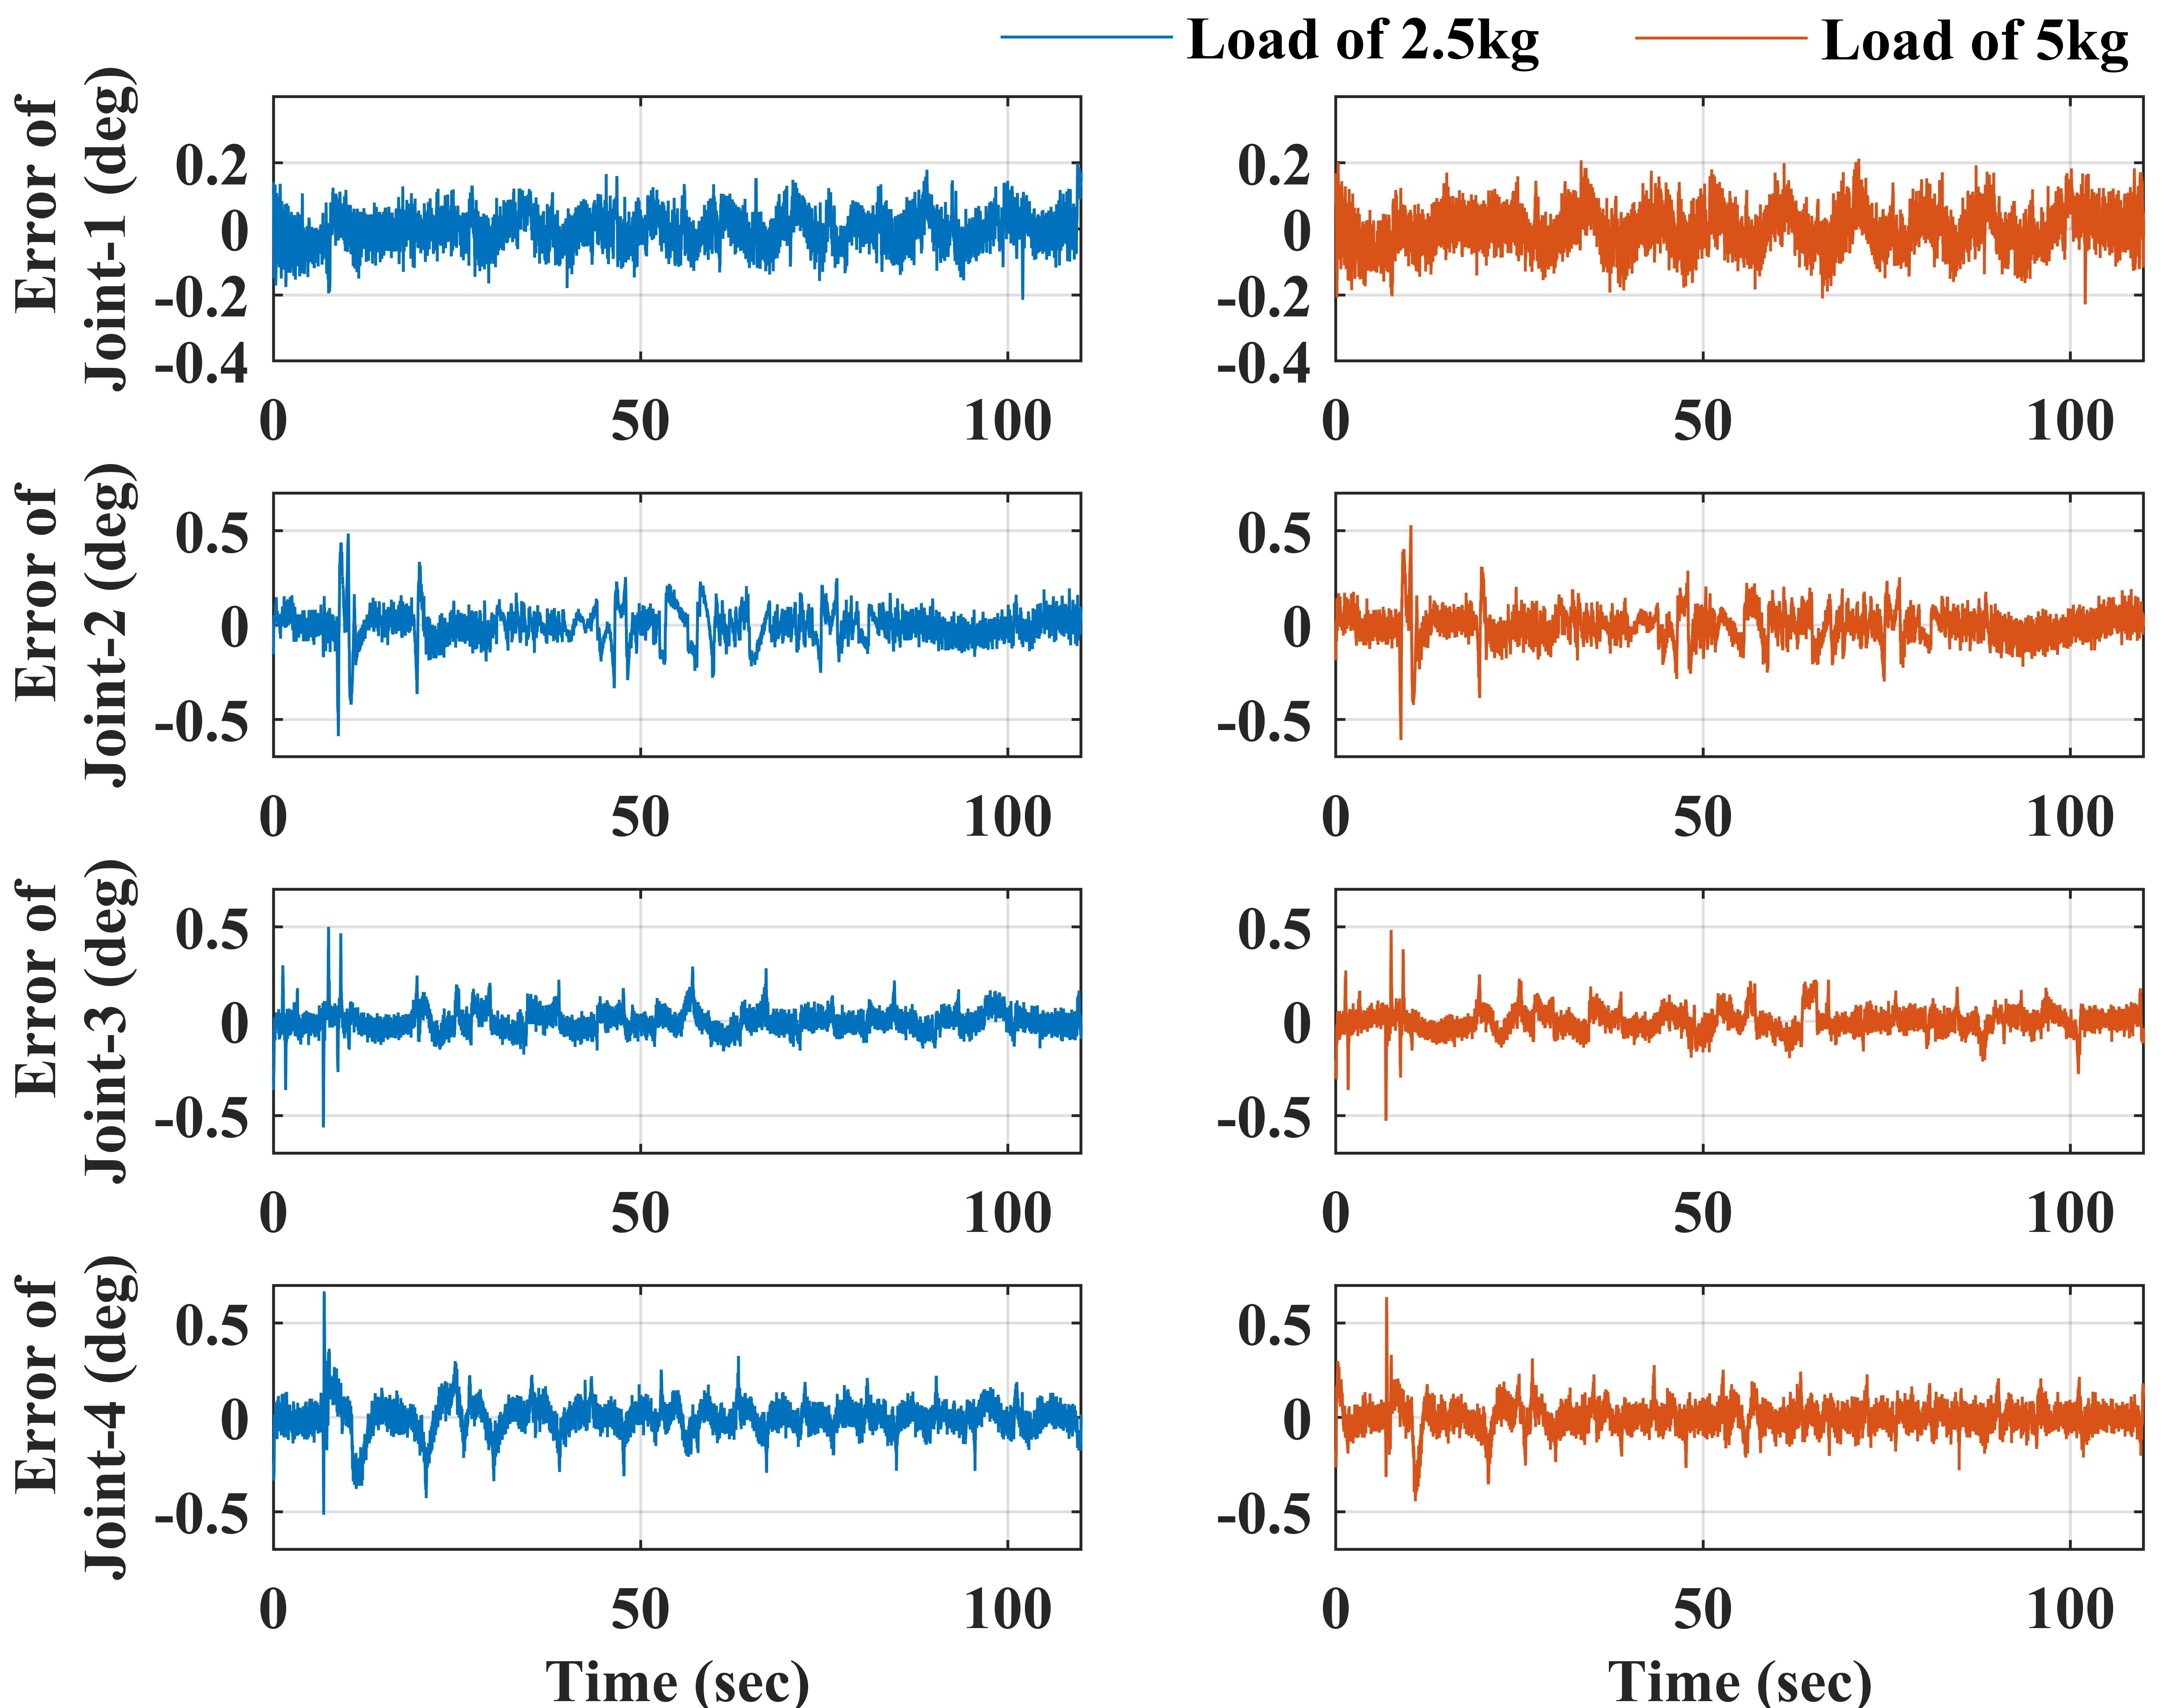

**Fig. 10. Tracking performance in joint space**

and acceleration is relatively limited, so it is not possible to fully stimulate the dynamic characteristics of the system. Due to the strong correlation between load mass and system velocity and acceleration, the estimation speed of mass is slowed down, but high estimation accuracy is still achieved. A mass of 2.35kg is estimated when the actual

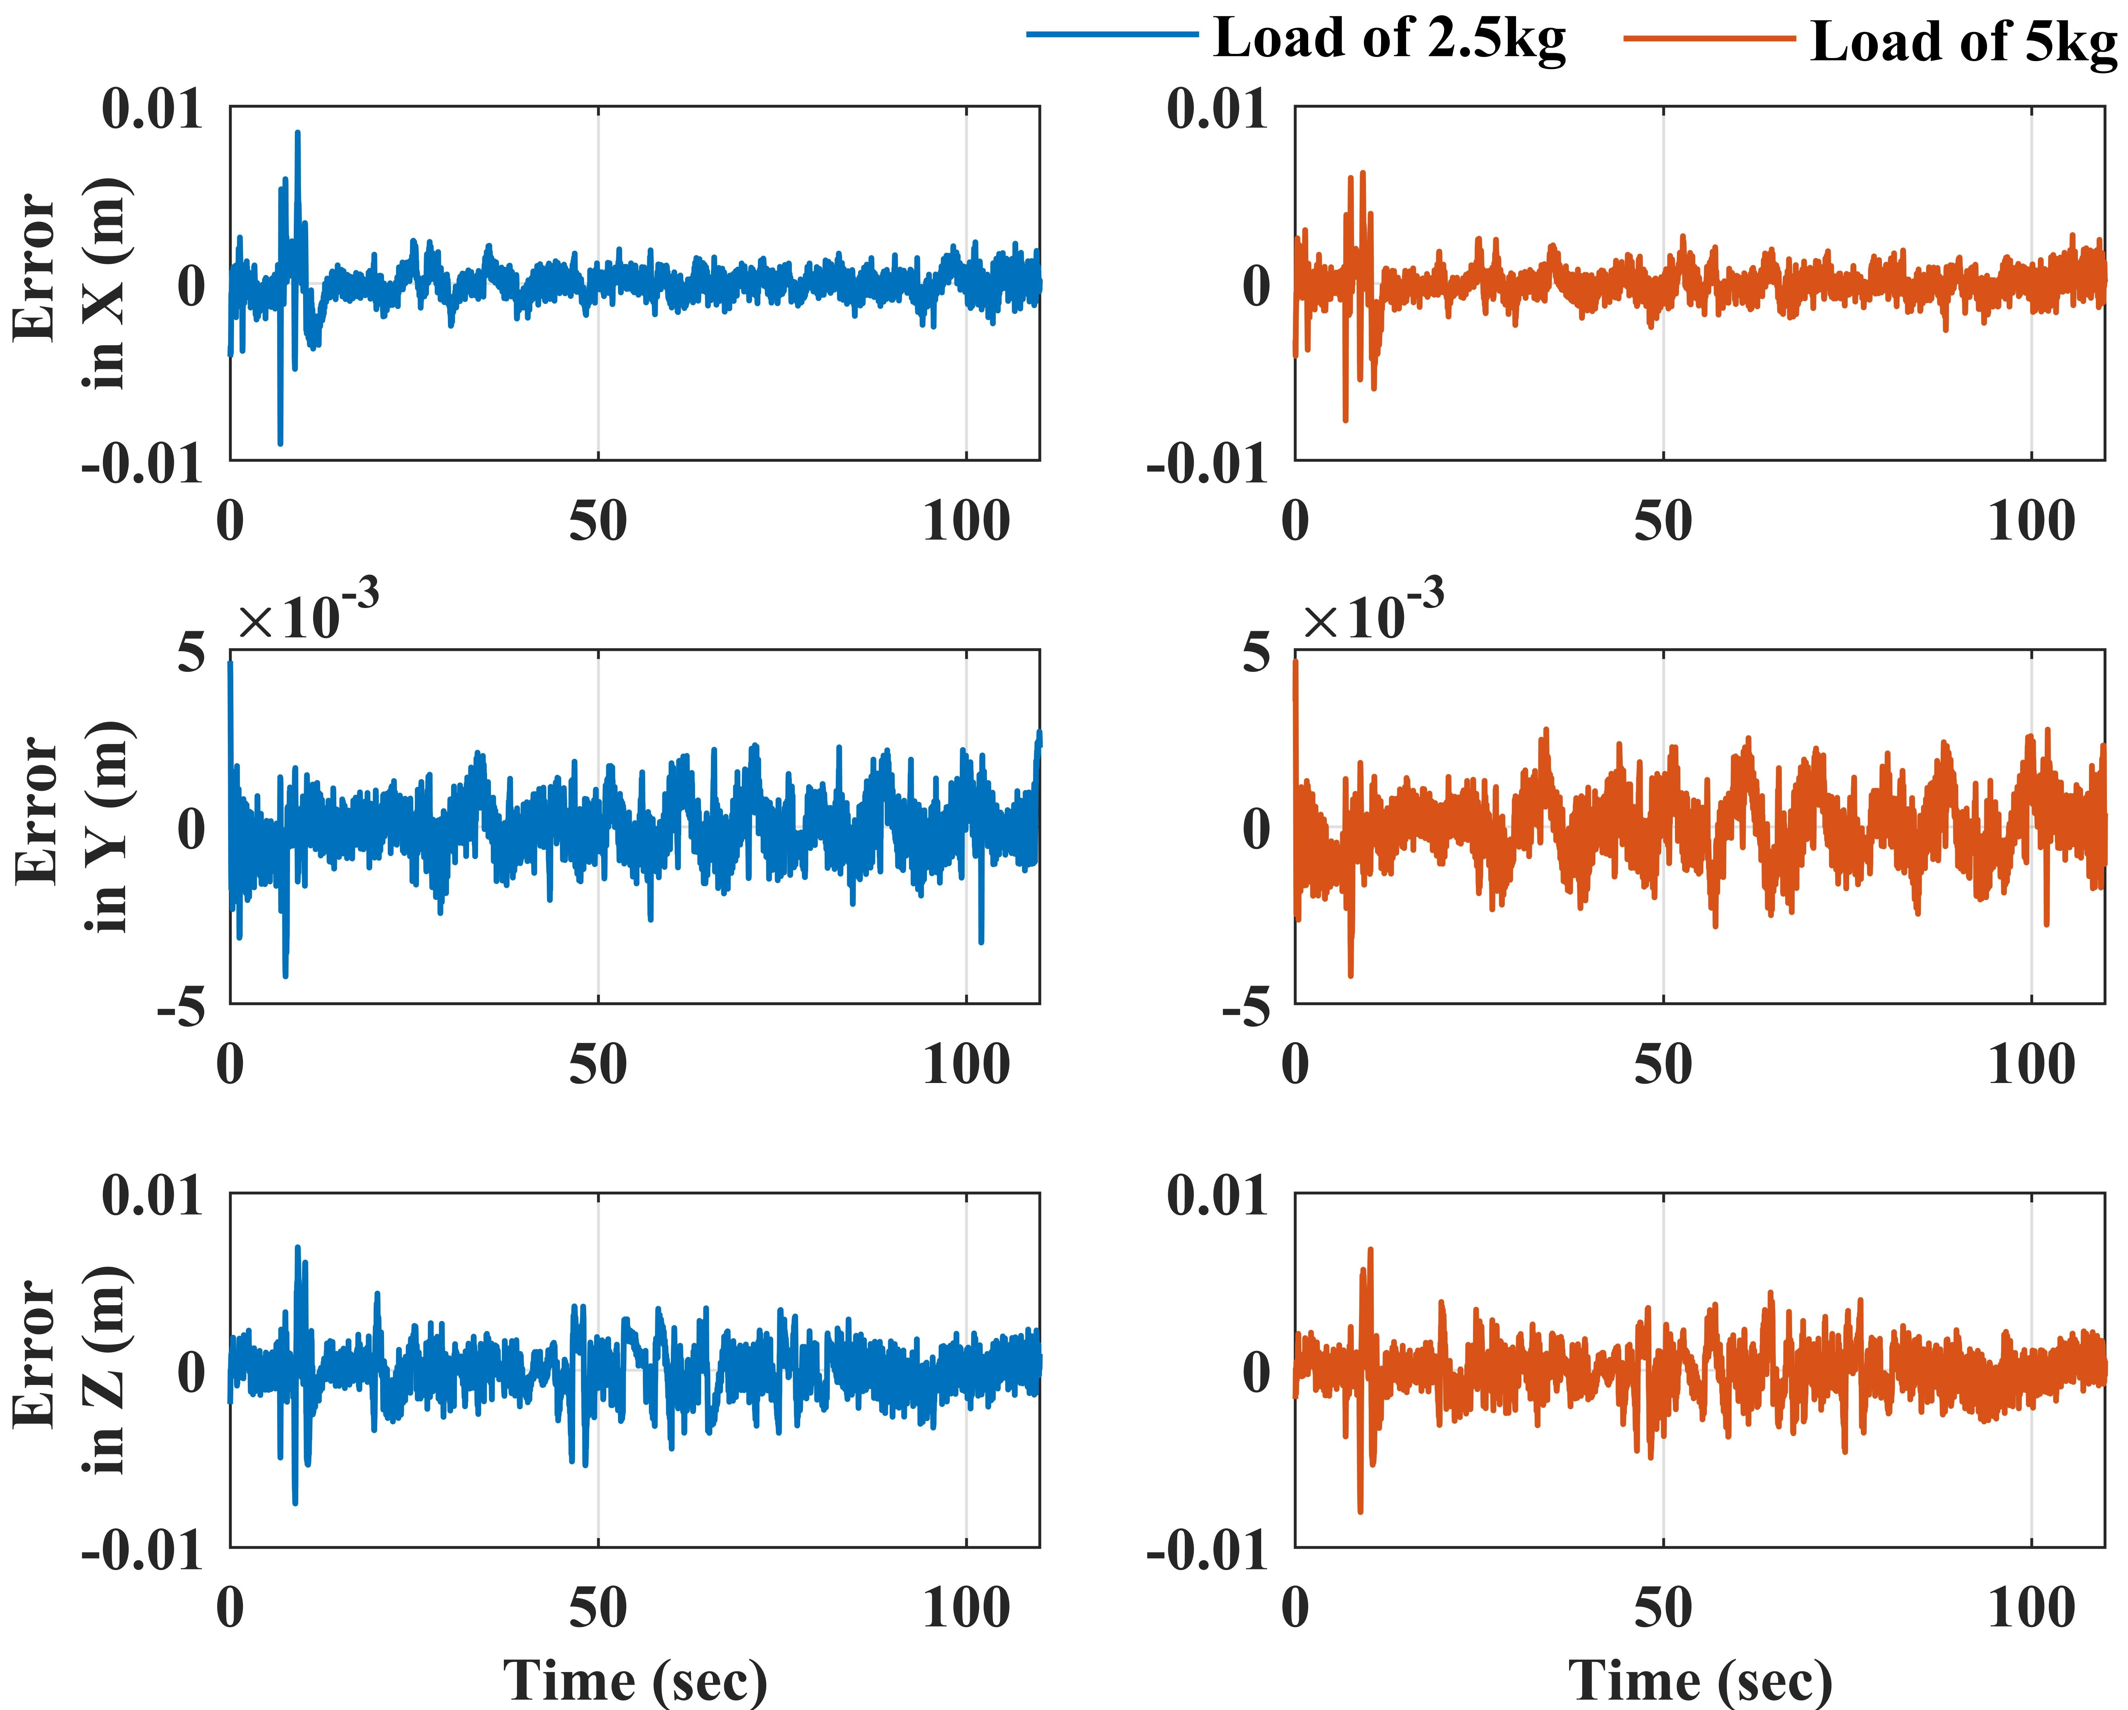

**Fig. 11. Tracking performance in Cartesian space**

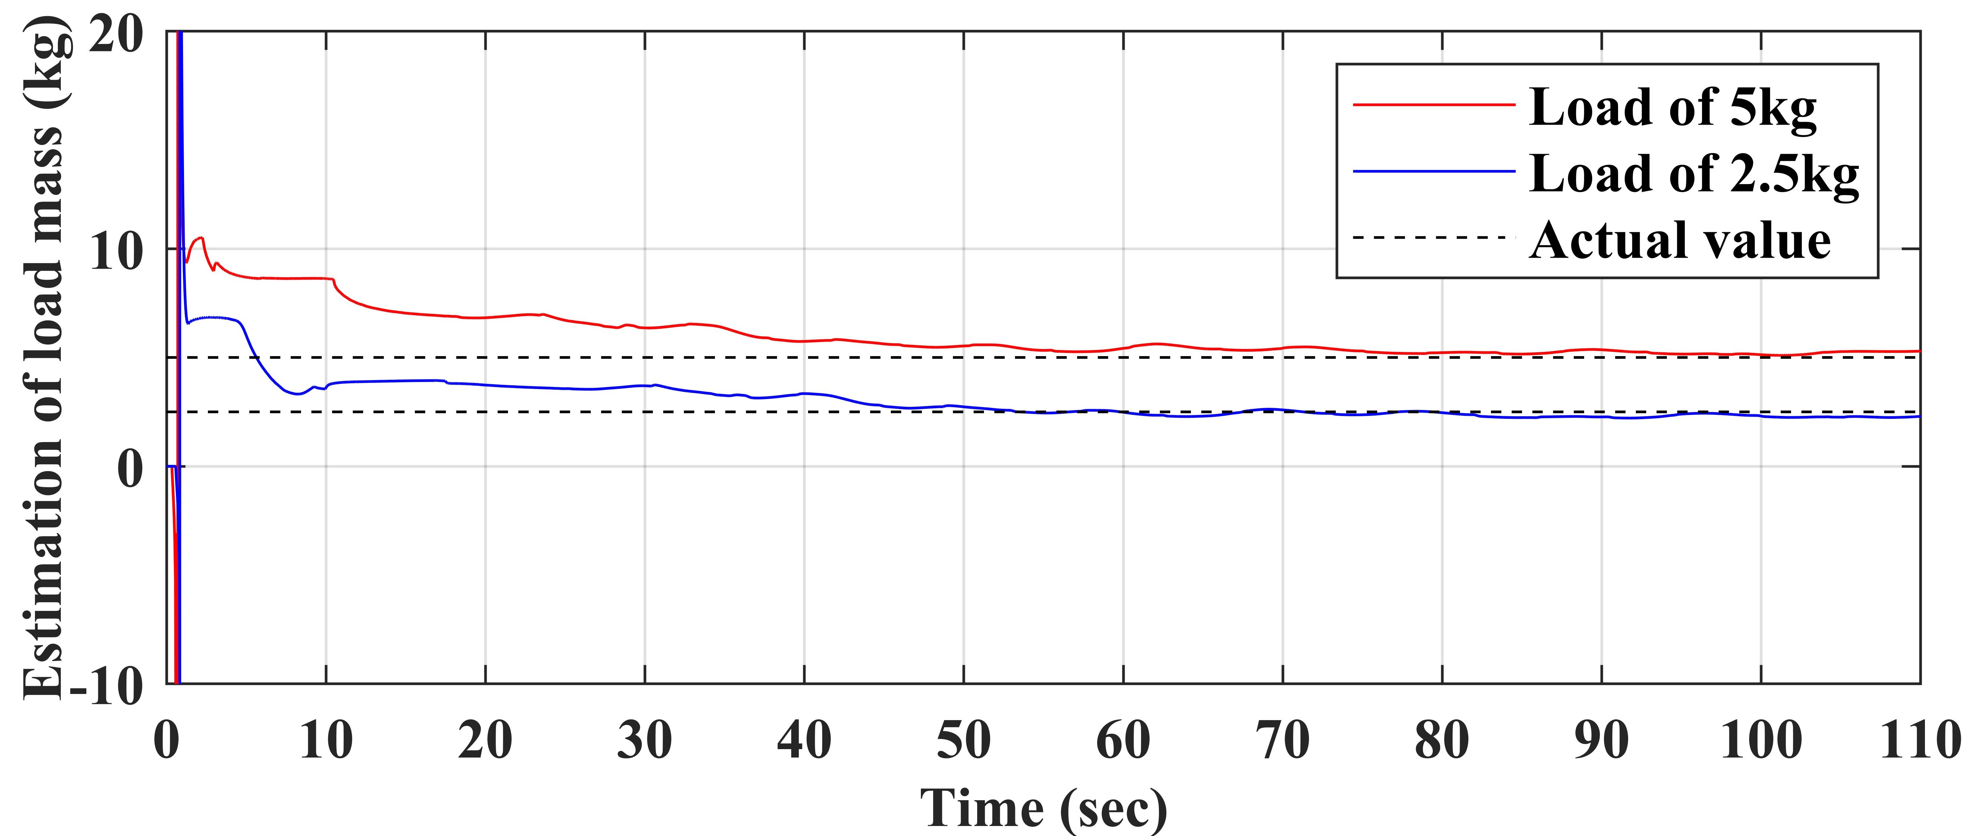

**Fig. 12. Adaptive curves in handling tasks**

weight is 2.5kg, and a mass of 5.22kg is estimated when the actual weight is 5kg. The estimation error is 6% and 4.4%, respectively.

**7. Conclusions**

This article proposes a direct/indirect adaptive robust controller (DIARC), which can compensate for the influence of the unknown load mass on hydraulic manipulators and can effectively estimate the mass of the unknown load mass. The high-order dynamics of the hydraulic manipulator with complex nonlinearity can be solved by adopting backstepping strategy which enables the controller to achieve high tracking accuracy. The unknown load mass is modeled and is included in the parametric space, a parameter adaptive law based on least squares method is designed in response to the demand for identification of unknown load mass, and the precise estimation of unknown load mass can be ensured. With the accurate estimation of the unknown load mass, the control accuracy can be further improved.

The control performance is experimentally verified on a four-DOF hydraulic manipulator. The experimental results show that the proposed controller with unknown load mass compensation reduces steady-state error and dynamic tracking error to a large extent. The accuracy of mass estimation is also relatively high. Overall, the controller can achieve load estimation without the need for pressure sensors, making it suitable for hydraulic manipulators under actual operating conditions. This study has considerable value for mining machinery, sorting machinery, hanging machinery and other industries that calls for precision control and load recognition.

**Acknowledment**

This work was supported by National Natural Science Foundation of China [Nos. 52075476]; Zhejiang Provincial Natural Science Foundation of China [No. LR23E050001]; and Fundamental Research Funds for the Central Universities [226-2023-00029].

**Renferences:**

1. L. Fang, T. Wang, W. Zheng, Z. Liu, L. Ming, X. Zheng, M. Wu, Consistency optimal coordination control of underground heavy-load robot in nonstructural environment, Rob. Auton. Syst. 159 (2023) 104281.

https://doi.org/10.1016/j.robot.2022.104281.

1. R. Capocci, G. Dooly, E. Omerdić, J. Coleman, T. Newe, D. Toal, Inspection-class remotely operated vehicles—a review, J. Mar. Sci. Eng. 5 (1) (2017).

<https://doi.org/10.3390/jmse5010013>.

1. L. Lyu, Z. Chen and B. Yao, Advanced valves and pump coordinated hydraulic control design to simultaneously achieve high accuracy and high efficiency, IEEE Trans. Control Syst. Technol. 29 (1) (2021) 236-248.

https://doi.org/10.1109/TCST.2020.2974180.

1. Z. Chen, F. Huang, W. Chen, J. Zhang, W. Sun, J. Chen, J. Gu and S. Zhu, RBFNN-based adaptive sliding mode control design for delayed nonlinear multilateral tele-robotic system with cooperative manipulation, IEEE Trans. Industr. Inform. 16 (2) (2020) 1236-1247.

<https://doi.org/10.1109/TII.2019.2927806>

1. J. Mattila, J. Koivumäki, D. G. Caldwell and C. Semini, A survey on control of hydraulic robotic manipulators with projection to future trends, IEEE/ASME Trans. Mechatron. 22 (2) (2017) 669-680.

<https://doi.org/10.1109/TMECH.2017.2668604>.

1. J. Hu, C. Li, Z. Chen, B. Yao, Precision motion control of a 6-dofs industrial robot with accurate payload estimation, IEEE/ASME Trans. Mechatron. 25 (4) (2020) 1821-1829.

<https://www.doi.org/10.1109/TMECH.2020.2994231>.

1. N. Adhikary, C. Mahanta, Integral backstepping sliding mode control for underactuated systems: Swing-up and stabilization of the Cart–Pendulum System, ISA Trans. 52 (6) (2013) 870-880.

<https://doi.org/10.1016/j.isatra.2013.07.012>.

1. Y. Yuan and W. Sun, An integrated kinematic calibration and dynamic identification method with only static measurements for serial robot, IEEE/ASME Trans. Mechatron. (2023) 1-12. In press

<https://doi.org/10.1109/TMECH.2023.3241302>.

1. R. Ding, M. Cheng, L. Jiang and G. Hu, Active fault-tolerant control for electro-hydraulic systems with an independent metering valve against valve faults, IEEE Trans. Ind. Electron. 68 (8) (2021) 7221-7232.

https://doi.org/10.1109/TIE.2020.3001808.

1. J. Yao, W. Deng, Z. Jiao, RISE-based adaptive control of hydraulic systems with asymptotic tracking, IEEE Trans. Autom. Sci. Eng. 14 (3) (2017) 1524-1531.

<https://www.doi.org/10.1109/TIE.2017.2694382>.

1. Q. Guo and D. Jiang, Based on rehabilitation robots of motion control PID research, In 2012 International Conference on Control Engineering and Communication Technology (2012) 394-397.

<https://doi.org/10.1109/ICCECT.2012.110>.

1. M. Cheng, J. Zhang, B. Xu, R. Ding and J. Wei, Decoupling compensation for damping improvement of the electrohydraulic control system with multiple actuators, IEEE/ASME Trans. Mechatron. 23 (3) (2018) 1383-1392.

<https://doi.org/10.1109/TMECH.2018.2834936>.

1. W. Shen, J. Wang, An integral terminal sliding mode control scheme for speed control system using a double-variable hydraulic transformer, ISA Trans. 124 (2022) 386-394.

https://doi.org/10.1016/j.isatra.2019.08.068.

1. B. Yao, F. Bu, J. Reedy and G. T. C. Chiu, Adaptive robust motion control of single-rod hydraulic actuators: Theory and experiments, In Proceedings of the 1999 American Control Conference (1999) 759-763.

<https://www.doi.org/10.1109/ACC.1999.783142>.

1. Y. Xia, Y. Nie, Z. Chen, Motion control of a hydraulic manipulator with adaptive nonlinear model compensation and comparative experiments, Machines 10 (3) (2022) 214.

<https://www.doi.org/10.3390/machines10030214>.

1. S. Zhou, C. Shen, Y. Xia, Z. Chen, and S. Zhu, Adaptive robust control design for underwater multi-DOF hydraulic manipulator, Ocean Eng. 248 (2022) 110822.

<https://doi.org/10.1016/j.oceaneng.2022.110822>.

1. Z. Chen, B. Helian, Y. Zhou and M. Geimer, An integrated trajectory planning and motion control strategy of a variable rotational speed pump-controlled electro-hydraulic actuator, IEEE/ASME Trans. Mechatron. 28 (1) (2023) 588-597.

https://doi.org/10.1109/TMECH.2022.3209873.

1. X. Yang, J. Yao, W. Deng, S. Yuan and X. Liang, Asymptotic adaptive motion control of hydraulic systems, In 40th Chinese Control Conference (CCC) (2021) 302-307.

<https://doi.org/10.23919/CCC52363.2021.9549358>.

1. L. Yin, J. Yao and Z. Yao, Finite frequency H∞ control for electro-hydraulic servo system with parameter uncertainties, In 5th International Conference on Advanced Robotics and Mechatronics (ICARM) (2020) 477-482.

<https://doi.org/10.1109/ICARM49381.2020.9195399>.

1. Z. Xu, L. Li, J. Yao, X. Hu, Q. Liu and N. Xie, State constraint control for uncertain nonlinear systems with disturbance compensation, IEEE Access 7 (2019) 155251-155261.

<https://doi.org/10.1109/ACCESS.2019.2947629>.

1. Z. Yao, J. Yao and W. Sun, Adaptive RISE control of hydraulic systems with multilayer neural-networks, IEEE Trans. Ind. Electron. 66 (11) (2019) 8638-8647.

<https://doi.org/10.1109/TIE.2018.2886773>.

1. J. Hou, D. Zhao and D. Ding, Forcefree control for hydraulic stewart manipulator, In IEEE 9th Joint International Information Technology and Artificial Intelligence Conference (ITAIC) (2020) 89-92.

<https://doi.org/10.1109/ITAIC49862.2020.9338984>.

1. [S. Chen](https://ieeexplore.ieee.org/author/37086041691), [Z. Chen](https://ieeexplore.ieee.org/author/37694472500), [B. Yao](https://ieeexplore.ieee.org/author/37286440100), [X. Zhu](https://ieeexplore.ieee.org/author/37897960200), [S. Zhu](https://ieeexplore.ieee.org/author/37281408900), [Q. Wang](https://ieeexplore.ieee.org/author/37404142400), [Y. Song](https://ieeexplore.ieee.org/author/37085682656), Adaptive robust cascade force control of 1-DOF hydraulic exoskeleton for human performance augmentation, IEEE/ASME Trans. Mechatron. 22 (2) (2017) 589-600.

<https://doi.org/10.1109/TMECH.2016.2614987>.

1. J. Koivumäki and J. Mattila, The automation of multi degree of freedom hydraulic crane by using virtual decomposition control, In 2013 IEEE/ASME International Conference on Advanced Intelligent Mechatronics (2013) 912-919.

<https://doi.org/10.1109/AIM.2013.6584210>.

1. J. Koivumäki, J. Mattila, Stability-guaranteed force-sensorless contact force/motion control of heavy-duty hydraulic manipulators, IEEE Trans. Robot. 31 (4) (2015) 918–935.

<https://doi.org/10.1109/TRO.2015.2441492>.

1. G. R. Petrović, J. Mattila, Mathematical modelling and virtual decomposition control of heavy-duty parallel–serial hydraulic manipulators, Mech. Mach. Theory 170 (2022) 104680.

<https://doi.org/10.1016/j.mechmachtheory.2021.104680>.

1. T. X. Dinh, T. D. Thien, T. H. V. Anh, K. K. Ahn, Disturbance observer based finite time trajectory tracking control for a 3 DOF hydraulic manipulator including actuator dynamics, IEEE Access, 6 (2018) 36798-36809.

https://doi.org/10.1109/ACCESS.2018.2848240.

1. T. Lin, Y. Lin, H. Ren, H. Chen, Z. Li, Q. Chen, A double variable control load sensing system for electric hydraulic excavator, Energy 223 (2021) 119999.

https://doi.org/10.1016/j.energy.2021.119999.

1. S. Duan, L. Chen, Z. Ma, G. Lu, Variable structure control with feedforward compensator for robot manipulators subject to load uncertainties, In 2010 11th International Conference on Control Automation Robotics & Vision (2010) 2367-2372.

<https://doi.org/10.1109/ICARCV.2010.5707248>.

1. W. Sun, Y. Yuan, Passivity based hierarchical multi-task tracking control for redundant manipulators with uncertainties, Automatica 155 (2023) 111159.

https://doi.org/10.1016/j.automatica.2023.111159.

1. A. Zeng, S. Song, J. Lee, A. Rodriguez, T. Funkhouser, TossingBot: Learning to throw arbitrary objects with residual physics, IEEE Trans. Robot. 36 (4) (2020) 1307-1319.

<https://doi.org/10.1109/TRO.2020.2988642>.

1. A. Colomé, D. Pardo, G. Alenyà, C. Torras, External force estimation during compliant robot manipulation, In 2013 IEEE International Conference on Robotics and Automation (2013) 3535-3540.

https://doi.org/10.1109/ICRA.2013.6631072.

1. H. L. Bartlett, B. E. Lawson and M. Goldfarb, Design, control, and preliminary assessment of a multifunctional semipowered ankle prosthesis, IEEE/ASME Trans. Mechatron. 24 (4) (2019) 1532-1540.

<https://doi.org/10.1109/TMECH.2019.2918685>.

1. F. Tessari, [R. Galluzzi](https://ieeexplore.ieee.org/author/37086048778), [A. Tonoli](https://ieeexplore.ieee.org/author/37322471100), [N. Amati](https://ieeexplore.ieee.org/author/37689122700), [G. Milandri](https://ieeexplore.ieee.org/author/37088535299), [M. Laffranchi](https://ieeexplore.ieee.org/author/37528362900), [L. De Michieli](https://ieeexplore.ieee.org/author/37087850759), An integrated, back-drivable electro-hydrostatic actuator for a knee prosthesis, In 2020 8th IEEE RAS/EMBS International Conference for Biomedical Robotics and Biomechatronics (BioRob) (2020) 708-714.

<https://doi.org/10.1109/BioRob49111.2020.9224278>.

1. A. Renner, H. Wind, O. Sawodny, Online payload estimation for hydraulically actuated manipulators, Mechatronics 66 (2020) 102322.

https://doi.org/10.1016/j.mechatronics.2020.102322.

1. A. Mohanty, B. Yao, Integrated direct/indirect adaptive robust control of hydraulic manipulators with valve deadband, IEEE/ASME Trans. Mechatron. 16 (4) (2011) 707-715.

<https://doi.org/10.1109/TMECH.2010.2051037>.

1. G.C. Goodwin, D.Q. Mayne, A parameter estimation perspective of continuous time model reference adaptive control, Automatica, 23 (1) (1987) 57-70.

<https://doi.org/10.1016/0005-1098(87)90118-X>.

**Appendix A**

Detailed expression of ,  and :



**Appendix B**

**Proof for theorem Ⅰ**

The Lyapunov function is defined as:

 (B.1)

Since , the derivative of Eq. (B.1) can be written as:

 (B.2)

Considering Eqs. 15 and 21, Eq. (B.2) can be expressed as:

 (B.3)

Noting Eq. 29 and , Eq. (B.3) can be expressed as:

 (B.4)

Then apply the comparison theorem, we can get:

 (B.5)

The boundedness of the closed-loop system signal is guaranteed. The relation between the Laplace transform of  and  can be written as:

 (B.6)

Therefore, if  is bounded,  will be bounded as well.

**Appendix C**

**Proof for theorem Ⅱ**

According to Ref [37], when  and PE condition is fulfilled,  when . The Lyapunov function can be defined as:

 (C.1)

The derivative of Eq. (C.1) can be written as:

 (C.2)

Since  and both  and  are bounded,  and . From Eq. (C.2), we can get  and . According to barbalat lemma  converges to 0 when .